In Atomic Absorption Spectroscopy (AAS), there are two main systems:
- Flame Atomic Absorption Spectroscopy (Flame AAS)
- Graphite Furnace Atomic Absorption Spectroscopy (GFAAS)
Therefore, the graphite furnace is not used in flame AAS; rather, it serves as an alternative to the flame and is employed in a more sensitive technique.

🔹 Definition of the Graphite Furnace
The graphite furnace is a tube made of graphite (carbon) used to gradually heat the sample inside the atomic absorption spectrometer instead of a flame.
The tube is electrically heated to temperatures exceeding 2500°C, causing the atoms within the tube to vaporize, and their absorption of light from the element-specific source (such as a hollow cathode lamp) is measured.

🔹 Stages of Graphite Furnace Operation
- Drying Stage:
The solvent is gently evaporated at 100–150°C.
- Ashing (or Charring) Stage:
Organic matter is decomposed, leaving the desired element at 400–800°C.
- Atomization Stage:
The tube is rapidly heated to 2000–2500°C, converting the elements into free atoms whose absorption is then measured.

🔹 Advantages Compared to Flame AAS
Parameter | Flame AAS | Graphite Furnace AAS (GFAAS)
Temperature | ~2300°C | Up to 3000°C
Sample volume | 1–2 mL | Only 10–20 µL
Sensitivity | Moderate | Very high (ppb–ppt range)
Speed | Faster | Slower (due to gradual heating)
Interferences | More frequent | Fewer, due to precise temperature control

🔹 Applications
The graphite furnace is mainly used for the analysis of trace and ultra-trace elements, such as:
Pb, Cd, Cu, Zn, Cr, Ni, and As
in water, soil, blood, plants, and other environmental or biological samples.

🔹 1. Longer atom residence time
- In Flame AAS, the atomized sample passes through the flame for only a few milliseconds.
- In Graphite Furnace AAS, atoms remain in the light path for 1–2 seconds or more, allowing more photons to be absorbed, which increases signal strength.
Result: stronger absorbance signal → higher sensitivity.

🔹 2. Complete atomization of small samples
- The furnace heats the sample step by step (drying → ashing → atomization), ensuring nearly all analyte atoms are converted to free atoms inside a small volume.
- In the flame, much of the sample is lost before full atomization occurs.
Result: more efficient use of the analyte → higher signal per microgram.

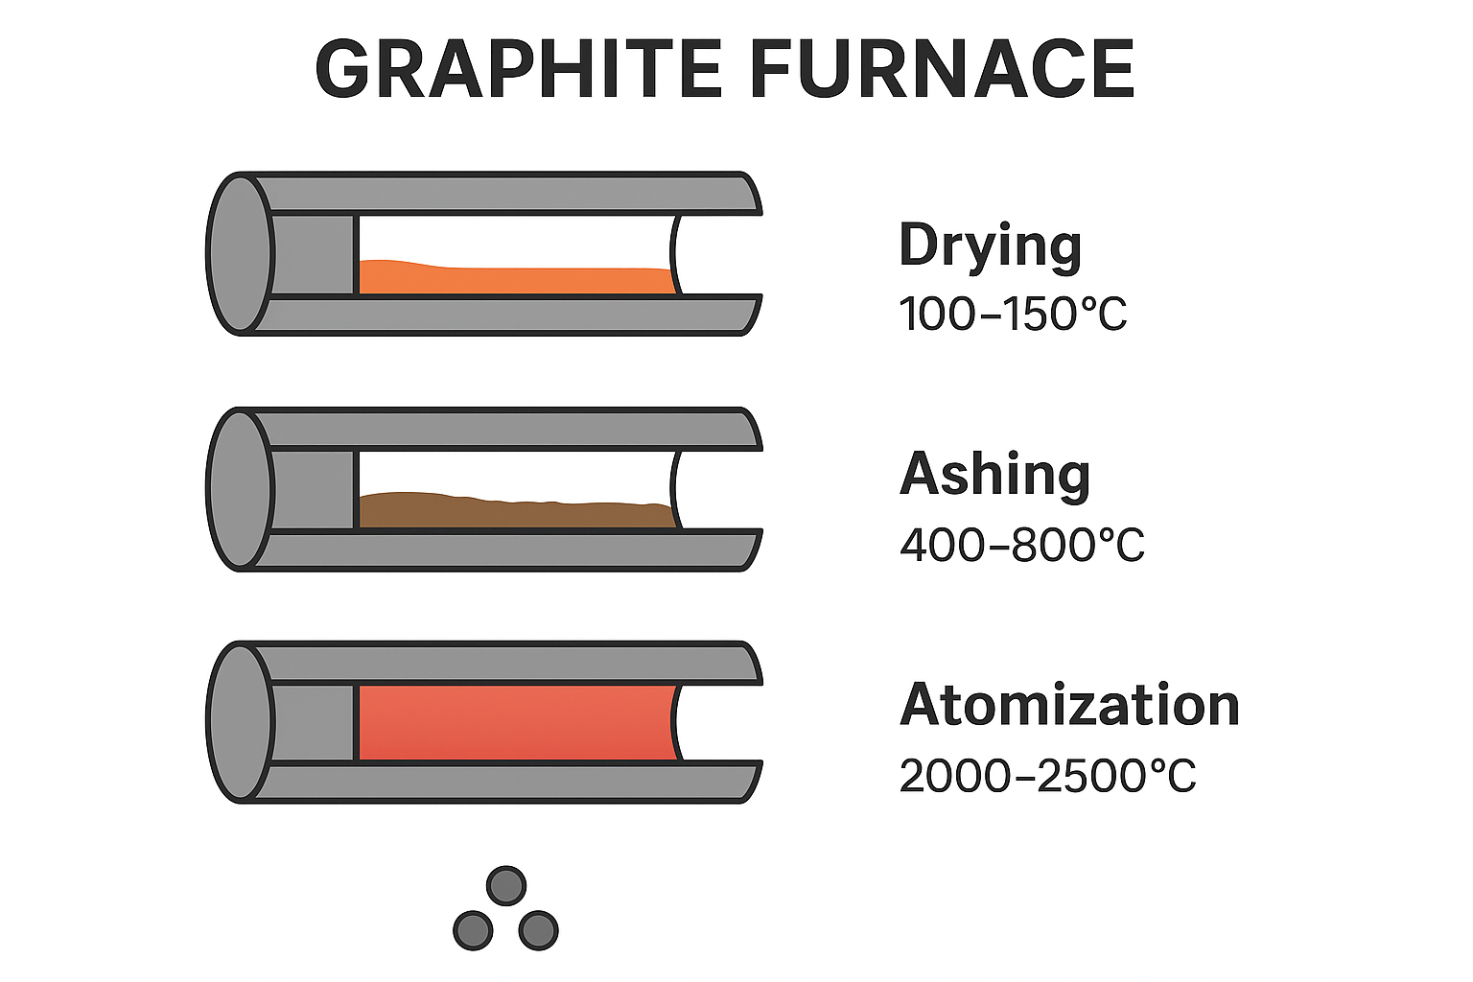

🔹 3. Small sample volume and high concentration of atoms
- Typical sample volume in GFAAS = 10–20 µL, confined inside a small graphite tube.
- All the atoms are concentrated in a very small space directly in the optical path.
Result: very high local atom density → stronger absorption.

🔹 4. No sample dilution by flame gases
- In flame AAS, the analyte is mixed with large amounts of fuel and oxidant gases, which dilute the vapor.
- In the graphite furnace, atomization occurs in a closed environment, minimizing dilution.
Result: higher effective concentration of atoms.

🔹 5. Lower background noise
- The furnace allows precise temperature control and background correction, reducing spectral noise and matrix interference.
Result: cleaner signal → better detection limit.

Overall Sensitivity Improvement
Technique | Detection limit (typical)
Flame AAS | micrograms per liter (µg/L)
Graphite Furnace AAS | nanograms per liter (ng/L) or even pg/L
So, GFAAS can be 100–1000 times more sensitive than flame AAS — ideal for trace and ultra-trace metal analysis (like Pb, Cd, or As in biological or environmental samples).

